MINI PROJECT
ON
ERP SYSTEM
Submitted to Uttaranchal School of Computing Sciences In
Partial fulfillment of the requirements for the degree
Of

BACHELOR IN COMPUTER APPLICATIONS (BCA)



SESSION (2025-26)

Under the supervision of Submitted By:
Mr. Deepak Kumar Vinayak
(Assistant Professor) B.C.A. (2nd SEMESTER)
USCS Section: - B


ACKNOWLEDGEMENT

I express my thanks to Mr. Deepak Kumar, Project Mentor, and Assistant Professor-USCS. He has been generous enough to provide me an opportunity and accepting my candidature for the most valuable guidance and affordable treatment given to us at every stage to boost my morale.

The most awaited moment of any Endeavour is successful completion, but nothing can be done successfully if done alone. Success is the outcome of contribution and consistent help of various persons and we thank those ones who helped us in successful completion of this project.
Primarily I would like to thank Prof (Dr.) Sonal Sharma, Director-USCS for providing a healthy and encouraging environment to study.

I profusely thankful to the Prof (Dr.) Sameer Dev Sharma, HoD-USCS for providing all the required resources in the successful completion of my project

Tanishq Bartwal
B.C.A. (2nd SEMESTER)
Enroll No. UU2509000358


DECLARATION

I hereby declare that the project report titled “ERP SYSTEM” was submitted by Tanishq Bartwal to Uttaranchal School of Computing Sciences. The project was done under the guidance of Mr. Deepak Kumar. I further declare that the work reported in this project has not been submitted and will not be submitted, either in part or in full, for the award of any other degree or diploma in this university or any other university or institute.

Vinayak
B.C.A. (2nd SEMESTER)
University Roll No. 2509000503



CERTIFICATE OF ORIGINALITY

This is to certify that the project entitles “ERP SYSTEM” by Vinayak has been submitted in the partial fulfilment of the requirements for the award of the degree of BCA from department of computer applications from Uttaranchal school of computing science Uttaranchal University, Dehradun.

The results embodied in this project have not been submitted to any other University or Institution for the record of any degree.

Under the guidance of:
Mr. Deepak Kumar Assistant Professor-USCS
Uttaranchal University Dehradun

TABLE OF CONTENTS

1.ACKNOWLEDGEMENT…………………………………………………….2
2.DECLARATION ……………………………………………………………..3
3.CERTIFICATE OF ORIGINALITY………………………………………….4
4.INDEX………………………………………………………………………...5
5.INTRODUCTION ……………………………………………………………7
6.OBJECTIVE…………………………………………………………………..8
7.SYSTEM ANALYSIS…………………………………………………………9
8.IDENTIFICATION OF NEED……………………………………………....10
9.PRELIMINARY INVESTIGATION………………………………………...11
10.FEASIBILITY STUDY…………………………………………………….12
11.PROJECT PLANNING…………………………………………………….13
12.PROJECT SCHEDULING (PERT & GANTT CHART)…………………..14
13.SOFTWARE REQUIREMENT SPECIFICATIONS (SRS)………………..15
14.SOFTWARE ENGINEERING PARADIGM………………………………16
15.DATA FLOW DIAGRAM………………………………………………….17
16.CONTROL FLOW DIAGRAM……………………………………………18
17.STATE DIAGRAM…………………………………………………………19
18.SEQUENCE DIAGRAM…………………………………………………..20
19.CLASS DIAGRAM………………………………………………………...21
20.CLASS RESPONSIBILITY COLLABORATOR………………………….22
21.COLLABORATION DIAGRAM…………………………………………..23
22.USE CASE DIAGRAM…………………………………………………….24

23.ACTIVITY DIAGRAM…………………………………………………….25
24.SYSTEM DESIGN…………………………………………………………26
25.TESTING…………………………………………………………………...27
26.SYSTEM SECURITY MEASURES……………………………………….28
27.FUTURE SCOPE…………………………………………………………..29
28.APPENDICES (CODING & OUTPUT)…………………………………...30
29.BIBLIOGRAPHY…………………………………………………………..38



INTRODUCTION
The Enterprise Resource Planning (ERP) is a software system that provides strong financial and collecting reports capabilities with automation along with managing, viewing project status, finances saving a large amount of time consumption and money.
The college ERP system allow to store and manage all important data in centralized data, mainly it helps in automate admission process, fee management, attendance tracking, result announcing. Overall, it reduces paperwork, increase efficiency of management with accuracy, helps to identify every teacher’s strength & weakness, often include parent portal for accessing student information like progress reports, attendance records and project & assignment submissions.
The goal of this project is to create a streamlined college ERP system that shows how student data, schedules, and project specifics arranged.



OBJECTIVE

The main objective of this project is to design and develop a College ERP System.
It provides a centralized platform to manage student details, timetable, and project records.
The system reduces manual work and improves accuracy through digital management.
It enhances data organization, accessibility, and overall efficiency in academic processes.
It also helps in understanding the practical implementation of ERP systems in institutions.

- To develop a system for storing and managing student data in a structured way.
-To create a centralized platform for accessing student details, timetable, and project records.
- To reduce manual paperwork and traditional record-keeping methods.
- To improve accuracy and efficiency in handling academic information.
- To design a user-friendly interface for easy access and interaction.
- To understand the basic working of ERP systems in educational institutions.
- To enhance data accessibility and quick retrieval of information.
- To demonstrate the practical use of software in solving real-world problems.



SYSTEM ANALYSIS

ERP system is revolutionary software that comes up solving many problems like automating repetitive tasks, significantly saves times, reducing errors, minimize costs related to labor, equipment. This also provides reporting & analytics tools which tracks department performance & tasks along with educational level tracking students records like project submission, fees submission. ERP system also comes up with advanced security measures to protect sensitive data that ERP systems data base stores this data base also helps to collect the feedback of customers in business, industry level and educational level.
More of challenges is faced before the ERP system was introduced in the markets in business area they often rely on manual data entry, difficulty in tracking data which resulting in loss of important information & overall decreases productivity and time. ERP system plays vital role in centralized database due to lack of its non-compliance risks serve penalties, operational disruptions & reputational damage, impacting financial stability in business areas.
In general, ERP systems are very important for improving efficiency in any organization. Whether it is a business organization or an academic institution, ERP software is very helpful for improving accuracy, saving time, and making better decisions.



IDENTIFICATION OF NEED
In many economical areas such as educational institutions, E-commerce & healthcare in the personal details, project records, reporting often manage manually. This makes difficult to organize, update & access data effectively. Manual data leads to errors, loss of information, time consumption. Therefore, the need of central power system emerges that can store information of a person detail in structured manner with easily accessible. The college ERP system helps to integrate important data in one platform, making easier to access, manage information in terms quickly accessing & accurately without errors being produced. This project is made to demonstrate a simplified ERP solution organize student details, timetable & projects information in a clear & efficient way.


PRELIMINARY INVESTIGATION
Preliminary investigation is the initial step for making a any type of software, project, assignments. In this investigation the requirements and feasibility of the project are examined. In education institution, student personal details, time table schedule are stored and maintained manually or in different system. This is the traditional method which leads to difficulty for updating, accessing or organizing information of students. Therefore, the college or any organization needs an ERP system providing a centralized system helps in storing every student’s detail in well and structured manner like time table schedule, personal details, project details through a simple well-organized interface. This overall, improves the accessing information, easily updating, fee management & easy to use by anyone.


FEASIBILITY STUDY
Feasibility study is the important step in system or project development which evaluates whether the proposed system can be developed successfully with available resources and time. It helps to determine whether the project is practically useful before implementation.
Technical feasibility:
The proposed ERP system is technically feasible because it uses basic internet connection with basic web technologies to show a student information. The required tools are internet connection and development platform these both are easily available. So, the system can be developed without any need of complex hardware.
Economic feasibility:
For development of this ERP system, it does not require any amount of cost. The tools will be use are freely available. This makes the development of this project cost-effective; therefore, this ERP system is economically feasible.
Operational feasibility:
This ERP system is simple, easy to understand for users. It allows to access the student details, timetable information, project titles to be viewed in structured manner. This improves data accessibility & reduces the difficulty of managing information manually.


PROJECT PLANNING
Project planning is the essential phase for developing a project or any system. Includes organizing & scheduling activities require for successful completion of project. The proposed ERP system in planning stage we focus on identifying the requirement related to student information management. The system includes the displaying the information of student personal details, timetable schedule and project titles he or she has done so far in a well-structured manner. After completion of requirements, the structure and layout of system are designed to ensure the clear presentation of information. Now the developing stage comes in which the included content properly arranged and testing the system to verify that all section function works properly or not. Proper planning ensures that the project is completed efficiently within the given time.


PROJECT SCHEDULING (PERT & GANTT CHART)
PERT Chart (Program Evaluation and Review Technique):
PERT is a project management tool used to schedule, organize and coordinate tasks within a project. For the ERP system, the PERT chart maps out all the activities from requirement gathering to final testing, identifying dependencies between tasks and estimating the time required for each phase.
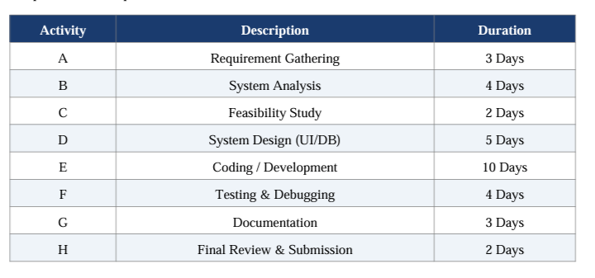
Gantt Chart:
A Gantt Chart is a bar chart that illustrates the project schedule. Below is the Gantt chart representation of the ERP System project showing the timeline of activities over 5 weeks.

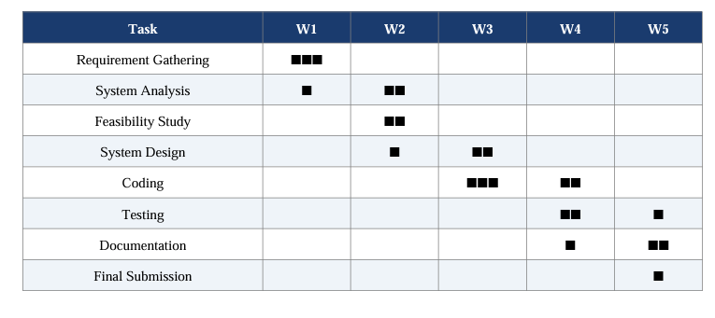

SOFTWARE REQUIREMENT SPECIFICATIONS (SRS)
- Functional Requirements:
- The system shall display student personal details (name, roll number, course,semester)
- The system shall show the student's timetable/schedule.
- The system shall list projects completed by the student.
- The system shall allow admin to add, update and view student records
- The system shall provide a login/logout feature for admin and students
2. Non-Functional Requirements:
- Performance: The system should load pages within 2 seconds.
- Usability: The interface should be simple and user-friendly.
- Security: Student data must be secured with access control.
- Reliability: The system should be available 99% of the time.
- Scalability: The system should support up to 1000 students.
3. Hardware Requirements:
- Processor: Intel Core i5 4th gen.
- RAM: Minimum 4GB.
- Storage: 50 GB HDD/SSD
- Internet Connection: Required for web interface.
4. Software Requirements:
- Operating System: Windows 10 / Linux
- Web Technologies: HTML, CSS, JavaScript
- Browser: Google Chrome / Mozilla Firefox • Text Editor: VS Code / Notepad+

SOFTWARE ENGINEERING PARADIGM

For the development of this ERP System project, the Waterfall Model of Software Engineering has been applied. The Waterfall Model is a linear sequential model in which development flows steadily downward like a waterfall through the phases of Requirements, System Design, Implementation, Testing, Deployment, and Maintenance.
Requirement Analysis: Gathering all the requirements related to student information, timetable and project data management.
System Design: Designing the user interface layout, data structure and flow of the ERP system.
Implementation: Writing HTML, CSS and JavaScript code to develop the web-based ERP interface.
Testing: Verifying that each section of the system functions correctly and displays accurate data.
Deployment: Making the system ready for use in the educational institution.
Maintenance: Updating and improving the system based on feedback and future requirements


1. Data Flow Diagram (DFD):
The context diagram shows the ERP System as a central process with the following external entities: Student (inputs login credentials, views data), Admin (manages student records), and Database (stores and retrieves all data). The system processes the inputs and outputs the required information to the respective users

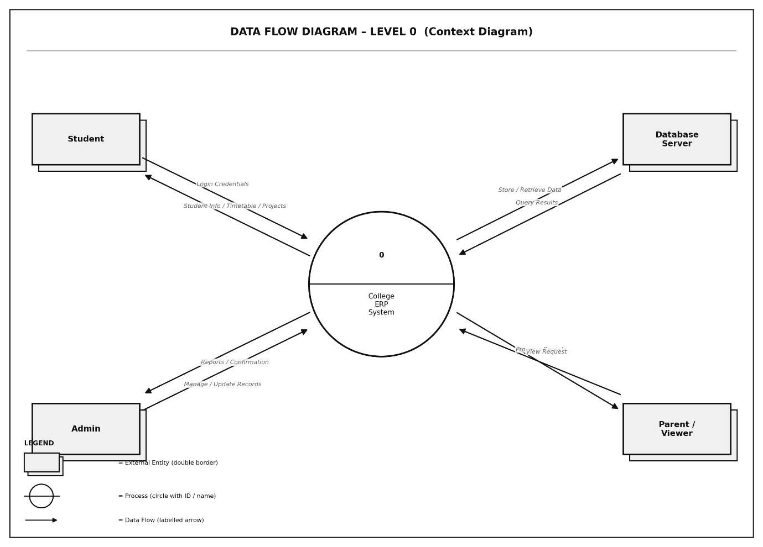


2. Control Flow Diagram (CFD)
A Control Flow Diagram (CFD) is a graphical representation that illustrates the sequence of operations or steps that a program or system follows during its execution. It shows the order in which instructions are executed, including decision points, loops, branches, and the overall logical flow from the start to the end of a process.
Control Flow Diagrams use standard symbols such as rectangles for processes/actions, diamonds for decision points, ovals or filled circles for start and end terminals, and arrows to show the direction of flow between steps.

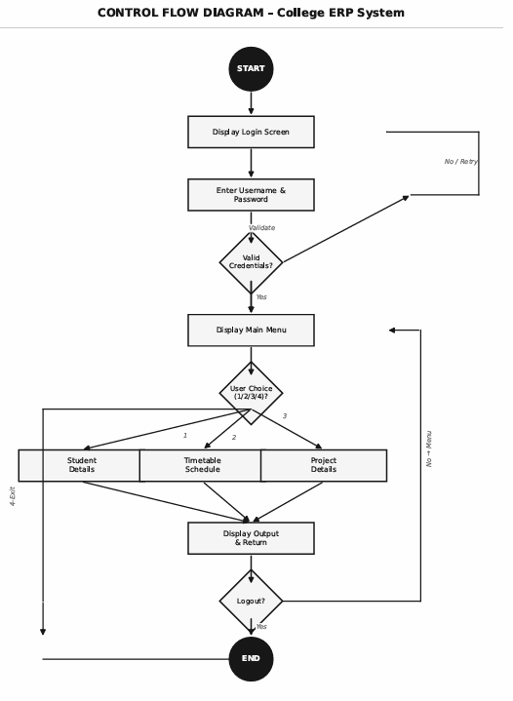


3. State Diagram
A State Diagram, also known as a State Machine Diagram or State chart, is a Unified Modelling Language (UML) behavioural diagram that describes the different states an object or system can be in throughout its lifecycle, and the transitions that cause it to move from one state to another. Each state represents a condition or situation during the life of an object.
State Diagrams use filled circles for the initial state, concentric circles for the final state, rounded rectangles for states, and arrows labelled with trigger events for transitions between states.
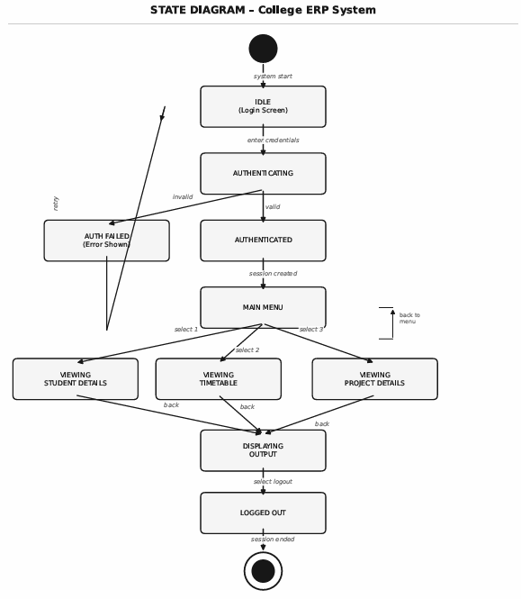


4. Sequence Diagram
A Sequence Diagram is a type of UML Interaction Diagram that shows how objects or components in a system interact with each other in a time-ordered sequence. It captures the order of messages exchanged between different participants (objects, modules, or actors) to accomplish a specific task or use case.
Sequence Diagrams use vertical dashed lines called lifelines to represent each participant, horizontal arrows to represent messages passed between them, activation boxes (thin rectangles on lifelines) to show when an object is active, and dashed return arrows to show responses. Time flows from top to bottom.

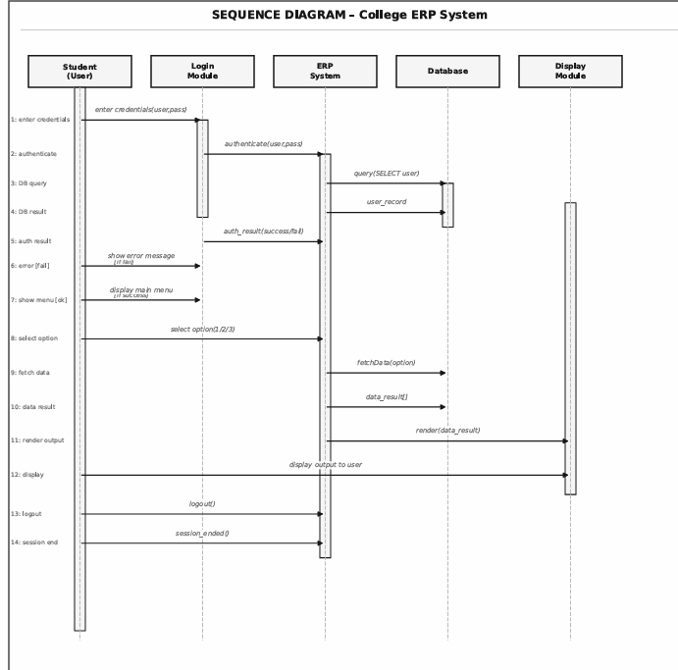


5. Class Diagram
A Class Diagram is a static structural UML diagram that describes the structure of a system by showing its classes, their attributes (data fields), methods (functions/behaviours), and the relationships between classes. It is one of the most widely used diagrams in object-oriented software design.
Each class is drawn as a rectangle divided into three compartments: the top contains the class name (bold), the middle lists attributes with their data types, and the bottom lists methods with their return types. Relationships such as association, aggregation, composition, dependency, and inheritance are shown using different arrow styles.

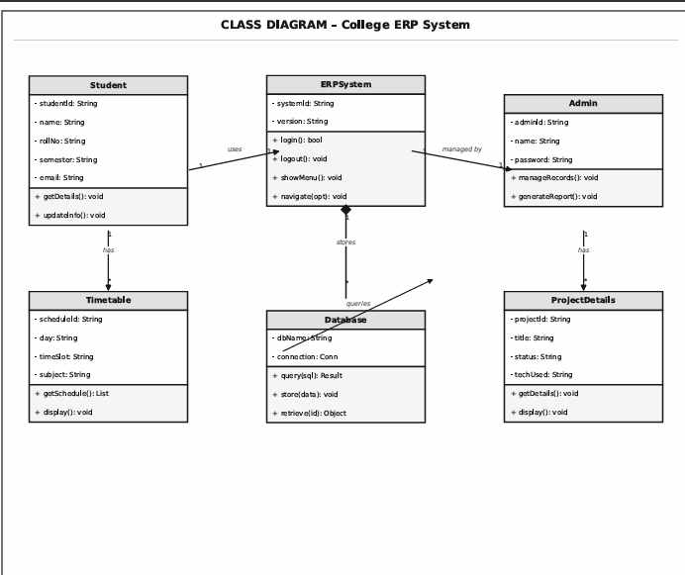


6. Collaboration Diagram
A Collaboration Diagram, also known as a Communication Diagram in UML 2.x, is a UML interaction diagram that shows how objects interact with each other to accomplish a task, with a focus on the structural relationships between the objects rather than the time sequence. Unlike the Sequence Diagram which emphasizes time ordering, the Collaboration Diagram emphasizes the network of object relationships.
In a Collaboration Diagram, objects are shown as rectangles labelled with the object name and class (e.g., s1: Student). Links (lines) between objects represent communication paths. Numbered arrows on the links show the sequence and direction of messages. The numbering (1, 2, 3...) indicates the order of interactions.

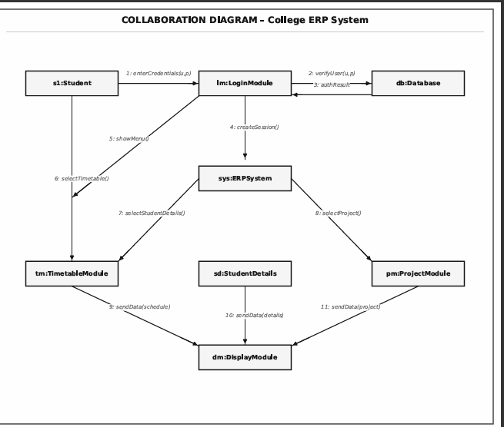


7. Use Case Diagram
A Use Case Diagram is a UML behavioural diagram that captures the functional requirements of a system from the perspective of its users (called actors). It shows what a system does (its use cases) and who interacts with it (its actors), without describing how the system accomplishes those functions internally.
Use Case Diagrams consist of: Actors (stick figures representing users or external systems), Use Cases (ellipses representing system functions or features), a System Boundary (a rectangle enclosing all use cases of the system), Association lines (connecting actors to use cases they participate in), and relationship notations such as «include» (one use case always includes another) and «extend» (one use case optionally extends another under certain conditions).
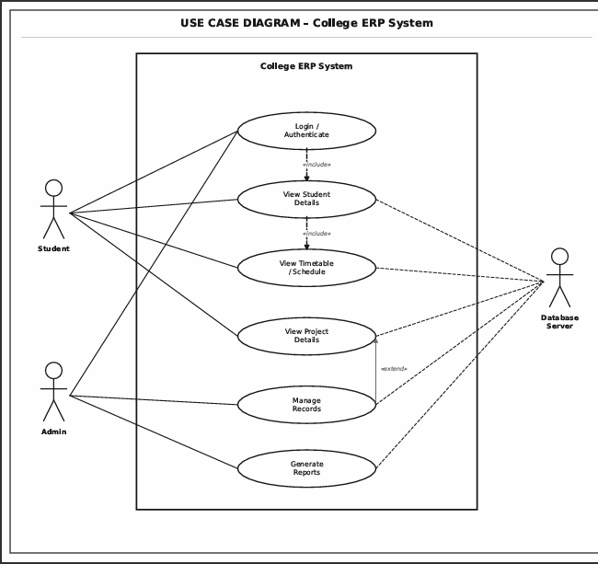

8. Activity Diagram
An Activity Diagram is a UML behavioural diagram that models the workflow or step-by-step activities of a system, process, or use case. It is similar to a flowchart but is more powerful because it supports parallel activities, swim lanes, decision nodes, and fork/join constructs. It shows the dynamic aspects of a system by modelling the flow of control from one activity to the next.
Activity Diagrams use: filled circles for the initial node, concentric circles (bulls-eye) for the final node, rounded rectangles for activities/actions, diamonds for decision/merge nodes, thick horizontal bars for fork/join (parallel flow), arrows for control flow, and swim lanes (vertical or horizontal partitions) to show which actor or component is responsible for each activity.

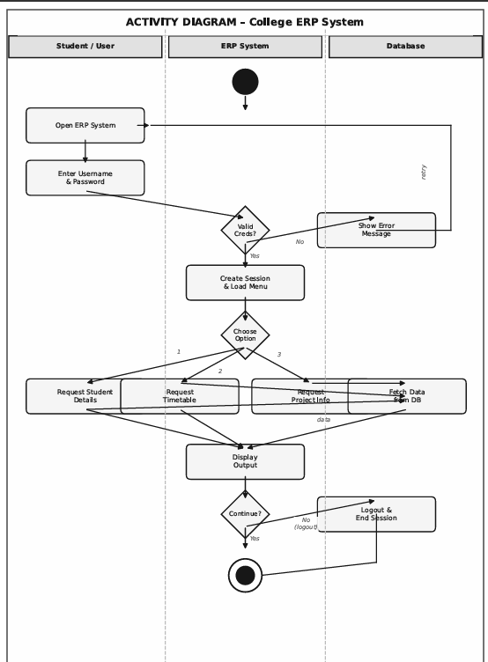


SYSTEM DESIGN
Modularization Details:
- Student Module: Manages and displays personal details of students.
- Timetable Module: Displays the schedule for each student.
- Project Module: Lists all projects undertaken by the student.
- Admin Module: Provides admin control over records.
- Authentication Module: Login/logout functionality
User Interface Design:
The user interface is designed to be clean, simple and easy to navigate. The home page displays the student profile with navigation links to Timetable and Projects. The design follows a card-based layout with a navigation bar at the top. The color scheme is professional and consistent throughout the application.
Modularisation Details:
Modularisation is the process of dividing a system into smaller and manageable parts called modules. Each module performs a specific function of the system and works together with other modules to complete the overall task. In the College ERP System, different modules can handle student details, timetable information, and project records separately. This approach makes the system easier to develop, understand, and maintain. It also helps in improving the organization and efficiency of the system.


TESTING
Testing is an important phase in software development to ensure the system works as expected. The following testing techniques and strategies were applied to the ERP System:

Testing Techniques Used:
- Unit Testing: Each individual module (Student, Timetable, Project) was tested separately.
- Integration Testing: All modules were tested together to ensure smooth data flow.
- Black Box Testing: The system was tested based on inputs and expected outputs without considering internal code.
- White Box Testing: Code logic was verified to ensure all paths were covered.
- User Acceptance Testing (UAT): The system was reviewed by peers to verify it meets the requirements
Test Cases:
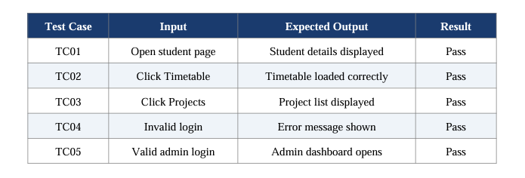


SYSTEM SECURITY MEASURES

System security is a critical aspect of any ERP system since it handles sensitive student and institutional data. The following security measures have been implemented or planned for this ERP system:

- Authentication: Login credentials are required to access the system, ensuring only authorized users can view or modify data.
- Authorization: Role-based access control ensures students can only view their own data while admins have full control.
- Data Validation: All input fields are validated to prevent incorrect or malicious data entry.
- Session Management: User sessions are managed securely to prevent unauthorized access after login.
- Secure Communication: The system is designed to use HTTPS protocol for secure data transmission over the network.
- Database Security: The student database is protected from unauthorized access through access control policies.


FUTURE SCOPE AND FURTHER ENHANCEMENT

The current ERP system is a simplified demonstration of how student information can be managed digitally. In the future, the following enhancements can be made to improve the system:
- Mobile Application: Develop an Android/iOS app version of the ERP system for better accessibility.
- Online Fee Payment: Integrate a payment gateway to allow students to pay fees online.
- Attendance Management: Add a real-time attendance tracking module using biometric or RFID.
- Result Management: Include automatic grade calculation and result publishing features.
- Parent Portal: A dedicated login for parents to monitor their child's academic progress.
- Notifications: Email/SMS alerts for fees due, exam schedules and announcements.
- Cloud Hosting: Host the ERP system on cloud platforms like AWS or Azure for 24/7 availability.
- Artificial Intelligence: Use AI for predictive analytics to identify at-risk students early


CODING
#include <stdio.h>
#include <string.h>
#include <stdlib.h>

// Function declarations
void printHeader();
void loginScreen();
void studentInfo();
void mainMenu();
void viewAttendance();
void viewProjects();
void viewTimetable();
void printLine(int width);
void printBoxTop(int width);
void printBoxBottom(int width);
void printBoxMid(int width);
void printBoxText(const char *text, int width);

// ==================== MAIN ====================
int main() {
printHeader();
loginScreen();
return 0;
}

// ============ BOX DRAWING (ASCII) =============
void printLine(int width) {
int i;
for (i = 0; i < width; i++) printf("-");

printf("\n");
}

void printBoxTop(int width) {
printf("+");
int i;
for (i = 0; i < width - 2; i++) printf("-");
printf("+\n");
}

void printBoxBottom(int width) {
printf("+");
int i;
for (i = 0; i < width - 2; i++) printf("-");
printf("+\n");
}

void printBoxMid(int width) {
printf("+");
int i;
for (i = 0; i < width - 2; i++) printf("-");
printf("+\n");
}

void printBoxText(const char *text, int width) {
int len = strlen(text);
int padding = width - 4 - len;
int left = padding / 2;
int right = padding - left;
printf("| ");
int i;

for (i = 0; i < left; i++) printf(" ");
printf("%s", text);
for (i = 0; i < right; i++) printf(" ");
printf(" |\n");
}

// ================== HEADER ====================
void printHeader() {
printf("\n");
printBoxTop(46);
printBoxText("ERP SYSTEM - MINI PROJECT", 46);
printBoxText("Tanishq | BCA-I Sem | Uttaranchal Univ", 46);
printBoxBottom(46);
printf("\n");
}

// =============== LOGIN SCREEN =================
void loginScreen() {
char username[50], password[50];

printBoxTop(46);
printBoxText("ERP SYSTEM - LOGIN", 46);
printBoxText("Uttaranchal University, Dehradun", 46);
printBoxBottom(46);

printf("\n Username: ");
scanf("%s", username);
printf(" Password: ");
scanf("%s", password);

if (strcmp(username, "tanishq") == 0 && strcmp(password, "erp123") == 0) {

printf("\n >> Login Successful! Welcome, Tanishq.\n\n");
studentInfo();
mainMenu();
} else {
printf("\n >> Invalid username or password!\n");
printf(" >> Please try again.\n\n");
loginScreen();
}
}

// ============= STUDENT INFO ===================
void studentInfo() {
printBoxTop(46);
printBoxText("STUDENT INFORMATION", 46);
printBoxMid(46);
printf("| %-14s: %-26s |\n", "Name", "Tanishq");
printf("| %-14s: %-26s |\n", "Roll No", "2401020347");
printf("| %-14s: %-26s |\n", "Father Name", "Mr. Rajesh");
printf("| %-14s: %-26s |\n", "Mother Name", "Mrs. Sunita");
printf("| %-14s: %-26s |\n", "Course", "BCA - I Semester");
printf("| %-14s: %-26s |\n", "Address", "45, Rajpur Road, Dehradun");
printBoxBottom(46);
printf("\n");
}

// ================ MAIN MENU ===================
void mainMenu() {
int choice;

printBoxTop(46);
printBoxText("MAIN MENU", 46);

printBoxMid(46);
printf("| 1. View Attendance |\n");
printf("| 2. View Project Topics |\n");
printf("| 3. View Timetable |\n");
printf("| 4. Logout |\n");
printBoxBottom(46);

printf("\n Enter your choice: ");
scanf("%d", &choice);
printf("\n");

switch (choice) {
case 1:
viewAttendance();
break;
case 2:
viewProjects();
break;
case 3:
viewTimetable();
break;
case 4:
printf(" >> Logged out successfully. Goodbye!\n\n");
printHeader();
loginScreen();
return;
default:
printf(" >> Invalid choice! Try again.\n\n");
}
mainMenu();
}

// ============== ATTENDANCE ====================
void viewAttendance() {
printBoxTop(56);
printBoxText("OVERALL ATTENDANCE", 56);
printBoxMid(56);
printf("| %-25s %8s %6s %6s |\n", "Subject", "Attended", "Total", "%");
printBoxMid(56);
printf("| %-25s %8d %6d %5d%% |\n", "Mathematics-I", 28, 30, 93);
printf("| %-25s %8d %6d %5d%% |\n", "Computer Fundamentals", 25, 30, 83);
printf("| %-25s %8d %6d %5d%% |\n", "English Communication", 27, 30, 90);
printf("| %-25s %8d %6d %5d%% |\n", "Programming in C", 26, 30, 87);
printBoxBottom(56);
printf("\n");
}

// ============= PROJECT TOPICS =================
void viewProjects() {
printBoxTop(46);
printBoxText("PROJECT TOPICS", 46);
printBoxMid(46);
printf("| %-5s %-37s |\n", "S.No", "Title");
printBoxMid(46);
printf("| %-5d %-37s |\n", 1, "Number Guessing Game");
printf("| %-5d %-37s |\n", 2, "MP3 Player");
printf("| %-5d %-37s |\n", 3, "ERP System");
printf("| %-5d %-37s |\n", 4, "Password Generator");
printf("| %-5d %-37s |\n", 5, "Weather Detector Software");
printBoxBottom(46);
printf("\n");
}


// =============== TIMETABLE ====================
void viewTimetable() {
printBoxTop(76);
printBoxText("WEEKLY TIMETABLE", 76);
printBoxMid(76);
printf("| %-14s %-11s %-11s %-11s %-11s %-11s |\n",
"Time", "Mon", "Tue", "Wed", "Thu", "Fri");
printBoxMid(76);
printf("| %-14s %-11s %-11s %-11s %-11s %-11s |\n",
"9:00-10:00", "Maths-I", "Prog in C", "English", "Comp Fund", "Maths-I");
printf("| %-14s %-11s %-11s %-11s %-11s %-11s |\n",
"10:00-11:00", "Comp Fund", "Maths-I", "Prog in C", "English", "Prog in C");
printf("| %-14s %-11s %-11s %-11s %-11s %-11s |\n",
"11:00-11:15", "Break", "Break", "Break", "Break", "Break");
printf("| %-14s %-11s %-11s %-11s %-11s %-11s |\n",
"11:15-12:15", "English", "Comp Fund", "Maths-I", "Prog in C", "Comp Fund");
printf("| %-14s %-11s %-11s %-11s %-11s %-11s |\n",
"12:15-1:15", "Prog in C", "English", "Comp Fund", "Maths-I", "English");
printBoxBottom(76);
printf("\n");
}

Website link:
https://bizbuddy-erp.lovable.app/
Git hub link:
https://github.com/Vinayak2684/ERP-system


OUTPUT
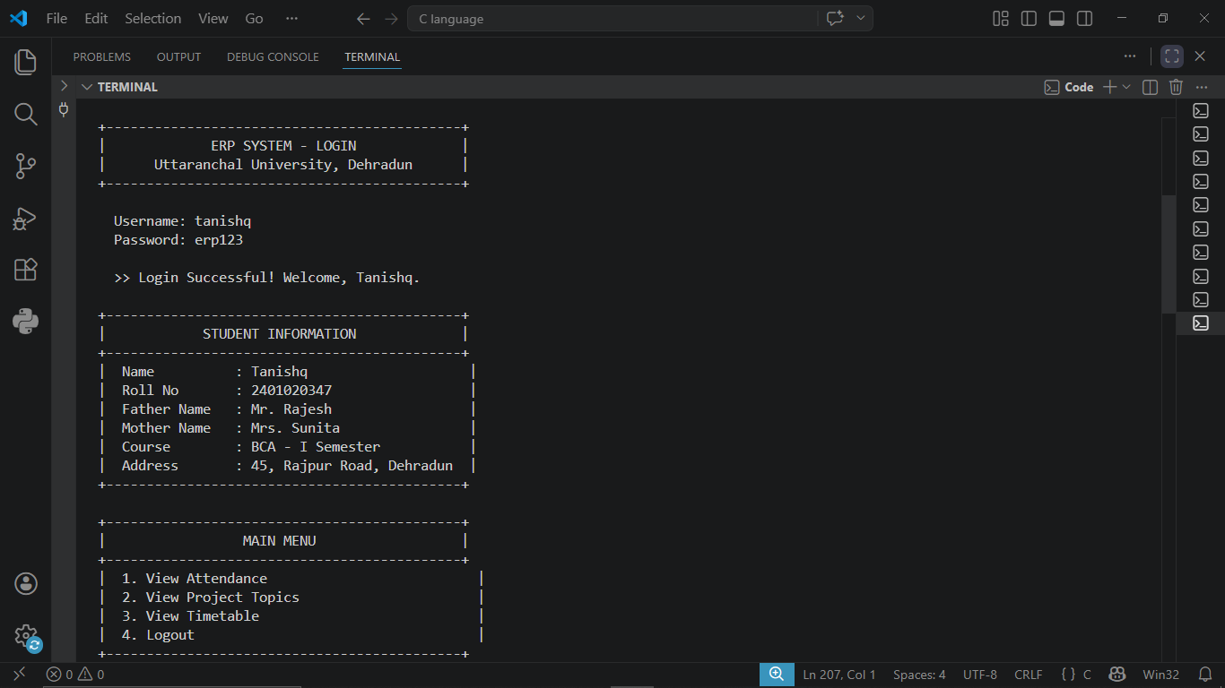

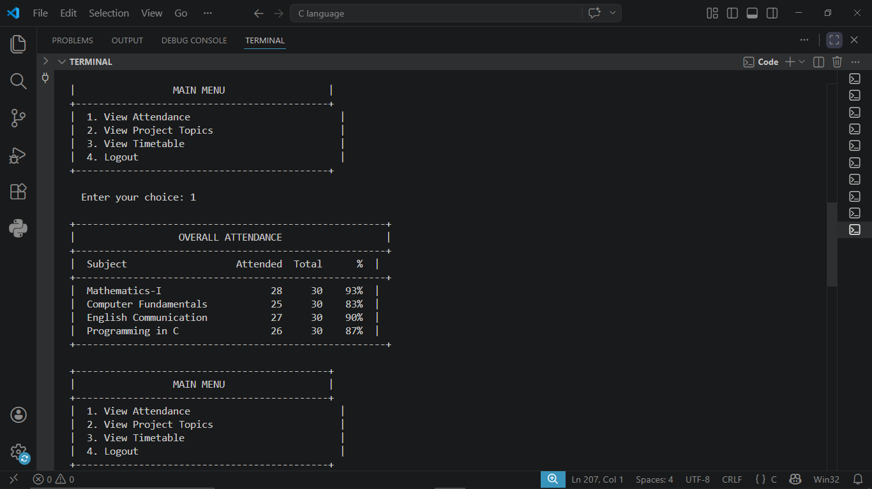


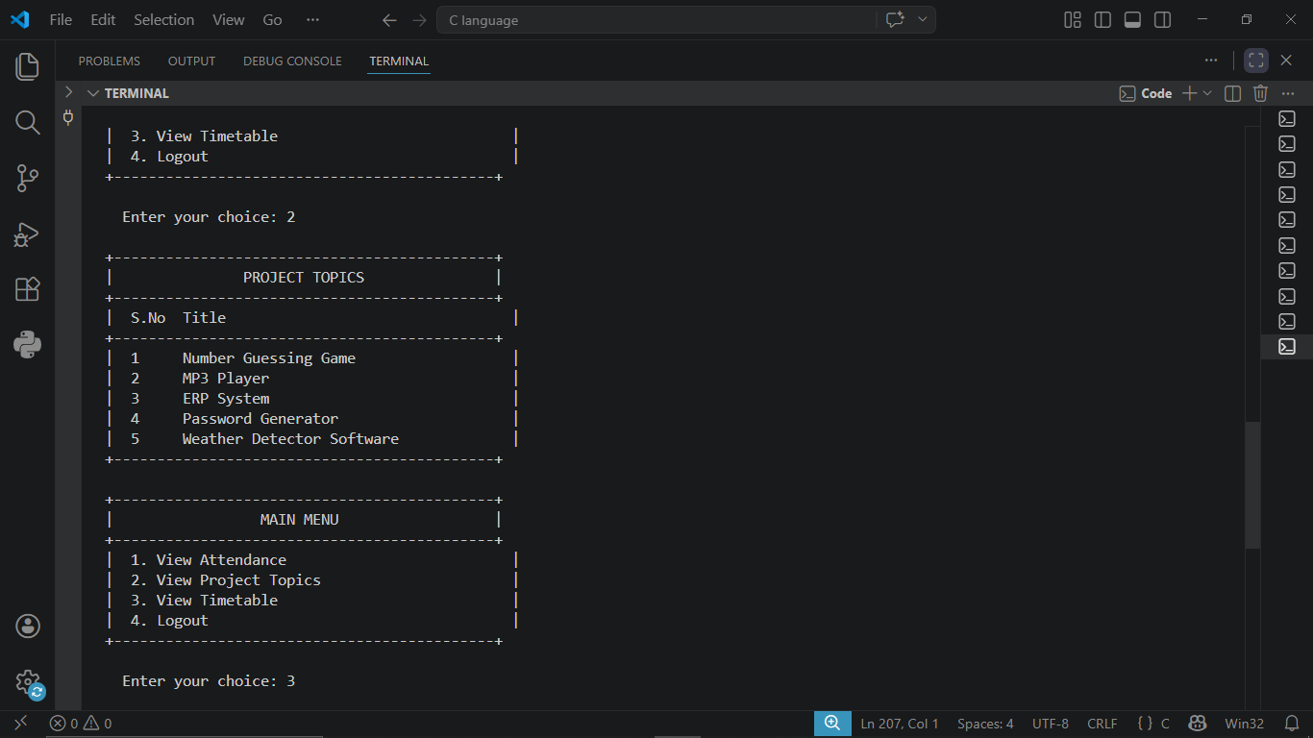

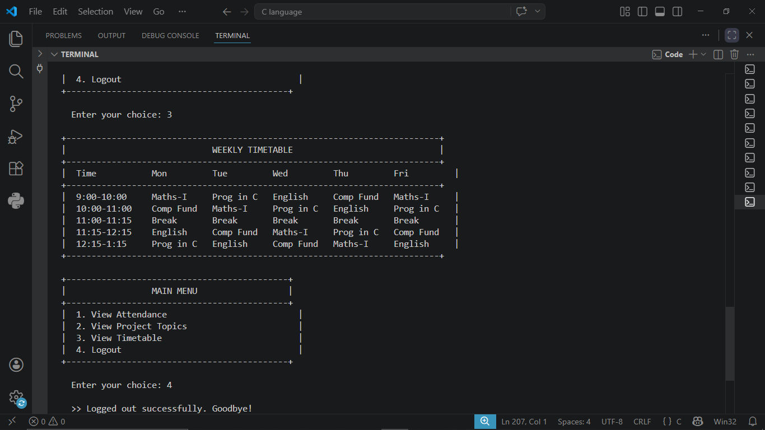



BIBLIOGRAPHY
-Websites referred:
-https://www.netsuite.com/portal/resource/articles/erp/what-companies-use-erp-systems.shtml
-https://nextos.in/blog/educational-erp-advantages-and-disadvantages/
-https://www.fwpr.com/what-is-erp/
-https://www.itconvergence.com/blog/challenges-faced-by-businesses-without-an-erp-system/
-https://erpsoftapp.com/blog/erpsoftapp-blogs-2/10-key-points-for-a-successful-erp-implementation-20
-Books referred:
-Reema Thareja – Introduction to C Programming
- Rajib Mall – Fundamentals of Software Engineering

